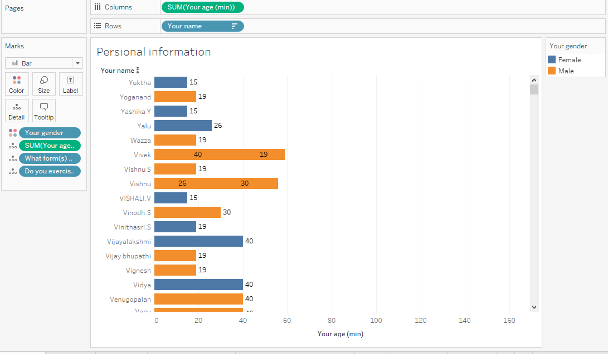

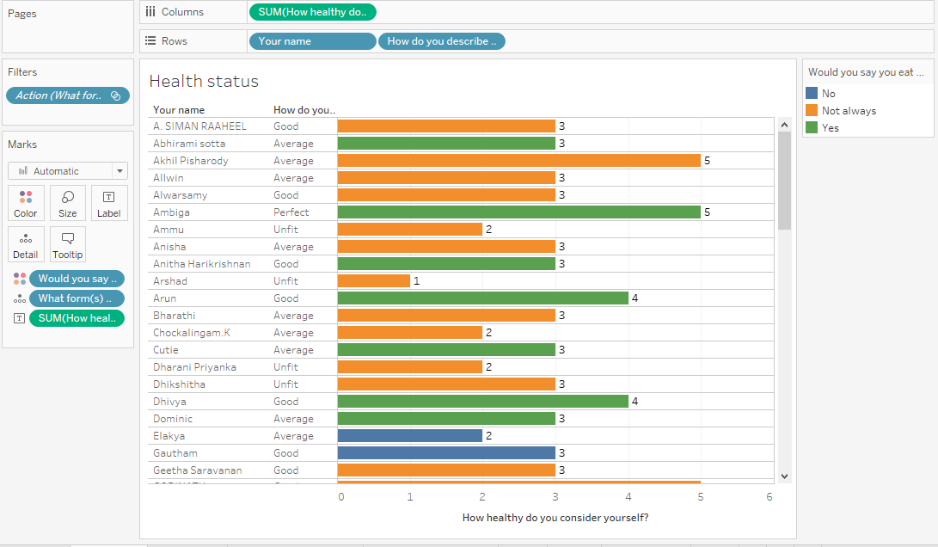

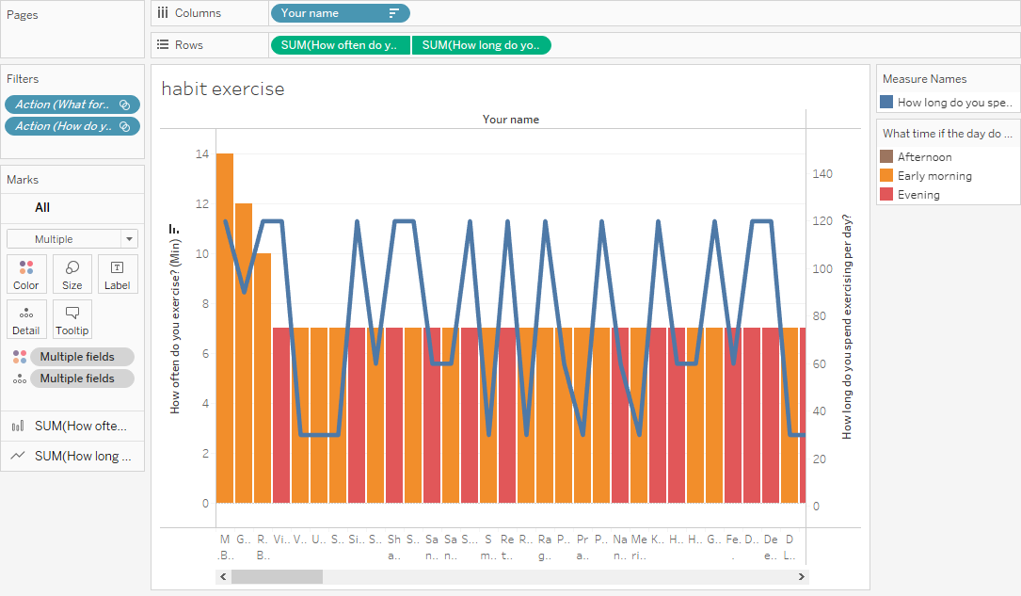

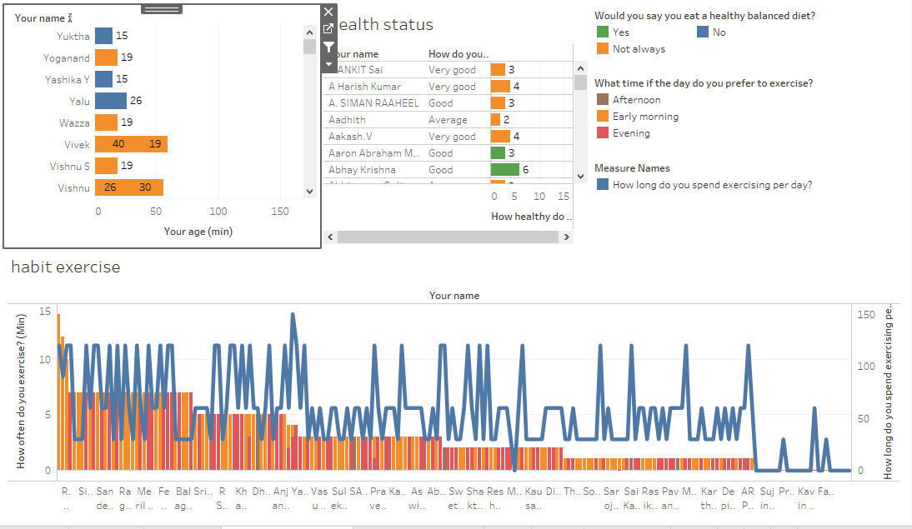

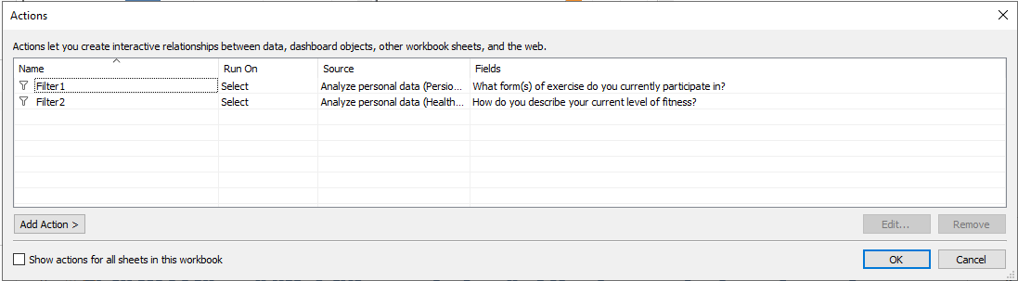

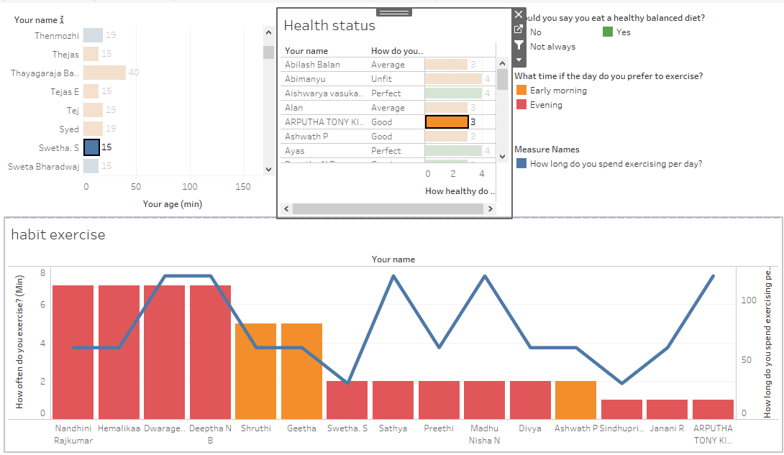

**Lọc**

**Code bảng purpose lọc từ bảng What motivate:**

if CONTAINS([What motivates you to exercise?], 'I want to be flexible') then "I want to be flexible" ELSEIF CONTAINS([What motivates you to exercise?], 'I want to relieve stress') then "I want to relieve stress"

ELSEIF CONTAINS([What motivates you to exercise?], 'I want to lose weight') then "I want to lose weight"

ELSEIF CONTAINS([What motivates you to exercise?], 'I want to achieve a sporting goal') then "I want to achieve a sporting goal"

ELSEIF CONTAINS([What motivates you to exercise?], 'I want to be fit') then "I want to be fit"

End

**Code bảng fillter gym lọc từ What forms:**

if CONTAINS([What form(s) of exercise do you currently participate in?], 'Gym') then "Gym" else "Other"

end

**Code bảng cản trở chế độ ăn uống lọc từ What prevents you from eating a:**

if CONTAINS([What prevents you from eating a healthy balanced diet, If any?], 'Temptation and cravings') then "Temptation and cravings" ELSEIF CONTAINS([What prevents you from eating a healthy balanced diet, If any?], 'Ease of access to fast food') then "Ease of access to fast food"

ELSEIF CONTAINS([What prevents you from eating a healthy balanced diet, If any?], 'Cost') then "Cost"

ELSEIF CONTAINS([What prevents you from eating a healthy balanced diet, If any?], 'Lack of time') then "Lack of time"

else "other"

end

